PARKTRACK: A QR-BASED GATEPASS SYSTEM FOR STUDENT VEHICLE MONITORING AND CAMPUS PARKING LOCATION

BASSER BANTAS
LYKA BENOY

AN UNDERGRADUATE CAPSTONE PROJECT SUBMITTED TO THE FACULTY
OF THE COLLEGE OF COMPUTING IN INFORMATION SCIENCES,
SOUTHERN CHRISTIAN COLLEGE, MIDSAYAP, COTABATO
IN PARTIAL FULFILLMENT OF THE REQUIREMENT
FOR THE DEGREE

BACHELOR OF SCIENCE IN INFORMATION TECHNOLOGY

APRIL
2026

Table of Contents
Page
Table of Contents ii
List of Tables iii
List of Figures iv
Chapter 1 Introduction 1
Project Context 1
Objectives 2
Scope and Limitations 3
Chapter 2 Review of Related Literature 5
Technical Background 5
Related Literature/System 14
Definition of Terms 19
Chapter 3 Theoretical Framework 21
Input 22
Process 22
Output 23
Chapter 4 Conceptual Framework 25
Input 26
Process 27
Output 28
Chapter 5 Design and Methodology 29
Project Methodology 29
Project Design 34
Literature Cited 67
Appendices 70

List of Tables
Table Title Page
1 Use Case Specification 41

List of Figures
Figure Title Page
- IPO 26
- RAD 30
- DFD Level 0 35
- DFD Level 1 36
- Gantt Chart 38
- System flow Admin 39
- System flow Student 40
- Use case Diagram 41
- Sequence Admin 44
- Sequence Student 45
- Sequence Registration 46
- Sequence Notifications 47
- Sequence Scanning 48
- Sequence Park/Unpark 49
- Sequence Records 50
- Class diagram 51
- ERD 53
- Admin log in page 55
- Dashboard 56
- Scan Gatepass 57
- Parking Monitor 58
- Registered 59
- Records 60
- Student Log in page 61
- Registration 62
- Dashboard 63
- Registration Update 64
- Virtual ID 65
- Reports 66

Chapter 1
Introduction

Project Context
Student vehicles and campus parking have been a major challenge in the contemporary learning institutions. Such traditional practices as manual registration and physical gate passes are usually ineffective, subject to mistakes and can jeopardize the security of the campuses. Such manual processes may lead to delays at the entrance of campuses and may make it hard to track authorized cars and parking activities by the administrators.
A good number of campuses continue to use paper-based gate passes and manual vehicle registration which is easily lost, duplicated or mismanaged. With more and more students and vehicles, the management struggles to monitor the entry of the vehicles as well as the vehicles that are allowed to park within the campus. Also, there is no real-time monitoring system, which makes controlling the movement of vehicles and their parking places more difficult.
QR code systems have now become a viable solution to identification and authentication with the development of mobile technology and web application. A QR based system enables quicker verification and less manual checking is provided. Students will be allowed to register their vehicles through a web-based registration system and be issued with a virtual ID that has a unique QR code. Such a QR can then be scanned at the gate of the campus to confirm entry and capture the time and date of entry.
The suggested system is a QR-based gatepass system, ParkTrack, which is aimed at enhancing the monitoring of vehicles on campus. The system will enable the students to enroll online and after approval by the administrators, they will receive a virtual ID with a QR code that will enable them to access the campus securely using the QR code. The students are able to indicate their parking position through a mobile application once they are within the campus, and this allows the administrators to have real-time tracking of the vehicle positions. Automation of registration, entry verification, and parking monitoring processes facilitates the enhancement of efficiency, minimization of manual errors, and campus security.

Objectives
To develop a QR-based gatepass system that improves campus vehicle monitoring by automating student registration, secure entry, and real-time vehicle location tracking.
1. To provide an online registration platform for students to obtain a virtual ID with a QR code.
2. To implement a QR code scanning system at the campus gate using the student’s virtual ID for secure vehicle entry.
3. To track student vehicle parking locations in real time for administrative monitoring and allow students to mark parking and unparking events through a mobile application.
4. To evaluate the usability and effectiveness of the ParkTrack system use a questionnaire survey among selected users.

Scope and Limitations
Scope
The system focuses with monitoring student vehicles and control activities in parking in the campus. It is intended to assist administrators with the monitoring of vehicle entering the campus and the vehicle parking status to enhance parking management organization in campuses.
The system requires the students to enroll with the help of the web-based system before accessing it. In the process of registration, the students are expected to give their personal details. Upon registration, the administrator goes through the registration and approves it after which the system generates a virtual ID with a unique QR code assigned to the student.
The campus gate also has a campus QR code scanner in the system. Students will produce their QR code on their mobile device when they get to the entrance. The scanner not only authenticates the QR code but also saves the student entry in the system database with the time and date added automatically.
Moreover, the mobile application will enable students to change their parking status. In case of students in their vehicles, students can use the Park option and when students leave the parking area they can use the Unpark option. These will automatically update the monitoring dashboard of the administrator by default.

Limitations
The system is not meant to support other vehicles besides student vehicles. It does not cover the vehicles belonging to visitors, those involved in the faculty, staff as well as other people who could come into the campus.
The quality of the parking location tracking will be dependent on the GPS of the mobile device of the student. The parking position read could not be fully accurate in case the GPS signal is inaccurate or weak.
The system functions best with a stable internet connection that supports its main functions. Student registration, the approvals by the administrator, the verification of QR codes at the gate, and the updating of the parking status are required to be supported by internet connectivity.
The other shortcoming of the system is that it can only be used in one campus setting. Assuming that the system should be applied in more than one campus or off-site parking facilities, further development and system modifications might take place.
Other features like parking reservation and processing of payments are also not available in the system. Moreover, the registration approval of the students can only be performed by the administrators, after which the system can be utilized.

Chapter 2
Review of Related Literature

Technical Background
WPF and MVVM
Windows Presentation Foundation (WPF) is a platform created by Microsoft to develop desktop applications having contemporary and dynamic user interfaces. It is an application that is used to design the layout of the application using XAML and enables the developer to include features like data binding and UI personalization. According to Chakraborty and Aithal (2023), WPF can be commonly applied in conjunction with the MVVM (Model-View-ViewModel) architecture, which tries to separate the interface with the logic and data. This facilitates the easier management, update and maintenance of the application.
The system in WPF is structured using the MVVM pattern with each aspect of the system having a particular role. The Data is handled by the Model, the interface presented by the View, and the ViewModel is the connection between the two through controlling the data flow and interaction with the user. Chakraborty and Aithal (2023) argue that the developers create the interface by means of XAML and bind the UI components to the ViewModel. User actions are also handled by commands thus preventing the direct connection between the interface and the program logic.
Aithal (2023) demonstrated the applicability of WPF through the MVVM architecture to a sample project. The findings underscored the fact that the method facilitates a gradual development of the system where each of the system components can be developed and assembled in an easy manner. The authors also discovered that MVVM when applied to WPF enhances the overall structure, maintainability and effectiveness of the application and is therefore a viable option to development of modern desktop applications.

Blazor
Blazor is a web platform that is part of the ASP.NET platform, which allows a developer to develop an interactive web application in C# instead of JavaScript. It facilitates client-side and server-side implementation, the client-side one of which is implemented with WebAssembly, and programs can be directly executed in the browser. According to Himschoot (2020), Blazor is a simple frontend and back-end to develop since it provides developers with the chance to work with a single programming language in the front-end and the back-end. This makes it easy and improves the maintainability of the code despite the fact that it is compliant with the existing web standards e.g. HTML and CSS.
Blazor is believed to create dynamic and responsive web apps in the form of C#, HTML, and CSS combined into reusable elements. The developers use Razor syntax to write the user interface and C# to write logic, which allows the smooth progression of the frontend and backend processes. Using Blazor WebAssembly, it is possible to develop applications, which can be fully executed on the browser since, according to Himschoot (2020), the .NET code can be translated into WebAssembly, and there is no need to maintain constant comm unication with the server. It can be used with real-time processing of information, high-performance visualization, and the ability to create single-page applications (SPA) capable of providing the sophisticated user experiences similar to those of desktops.
The effectiveness of Blazor has been proved with the help of recent research on the performance and real-time data processing. Himschoot (2020) showed that with the appropriate optimization, the Blazor WebAssembly applications are capable of processing and visualizing large quantities of data such as millions of data points in a second. The other reason which was brought up by the study was that it is possible to carry out performance improvement with techniques such as binary data transfer and ahead-of-time (AOT) compilation. In addition, Himschoot (2020) emphasized that in the modern web development, Blazor is becoming more popular since it is developed to write a web application using a single language, C#, and has the potential to be integrated with the .NET ecosystem. These findings confirm the fact that Blazor is a robust and efficient solution to the creation of scalable and high-performance applicant web applications.

ASP.NET CORE WEB API
Service-Oriented Architecture (SOA) is a form of software architecture that provides functionality of a system as loosely connected services that may be invoked by other software running over a network. Such services allow exchange of communication between various platforms such as web systems, mobile and desktop systems using common protocols. Nevertheless, software architecture has evolved to be more flexible systems like microservices than monolithic systems (where all components are combined into application one gigantic and large). Microservices is a more advanced form of the SOA in which the application is fragmented into separate albeit independent services with single distinct functions. According to Pattankar and Hurbuns (2017), the necessity of this evolution was the necessity to have scalable systems, maintainable systems, and technology-independent systems.
SOA and microservices are in application in the process of ensuring that different components of the system connect to each other through web services or APIs. Services exchange tasks with other services using a lightweight protocol such as HTTP and REST. Representational State Transfer (REST) as developed by Roy T. Fielding is a set of principles that characterize network based applications. These include stateless communication, client server separation, and are common HTTP protocols, i.e., GET, POST, PUT, and DELETE. Pattankar and Hurbuns (2017) claim that the flexibility and interoperability of systems increase due to the fact that Web APIs developed with the assistance of the REST protocol allow interacting with the system using different clients without necessarily involving a specific programming language and platform.
SignalR employs signalr in order to facilitate real time communication between clients and servers by having unbroken connections through which transmission of data occurs in real time without the need to depend on repeating requests in the form of HTTP. Aguilar (2014) notes that SignalR uses the most efficient means of transport, including WebSockets or long polling, automatically, based on the capabilities of the system, which makes it simpler to add live features such as messaging and notifications. It offers low-level persistent connections as well as high-level hubs that enable a smooth interaction between the server and clients and also the asynchronous communication group messaging, and automatic connection management, which are reliable and scalable to real-time application performance.
The use of SOA and microservices has been widely reported in modern software development. Pattankar and Hurbuns (2017) explained why the monolithic systems in organizations were eliminated and cited the challenges such as scaling, complex deployments, and interconnected elements as some of the problems. Microservices address these concerns, and they allow deployment to be independent, develop faster, and have greater scalability. In addition, REST-based APIs have become popular because they are easy and useful in managing distributed systems. They suggest their research at the usage of such architectures in the contemporary applications to develop the high-performance and scaled systems.

.NET MAUI
NET Multi-platform App UI (.NET MAUI) is a cross-platform software creation platform created by Microsoft that enables a programmer to create mobile and desktop software using a unified codebase. It is also created to accelerate the development process since it allows applications to be written on various platforms, including Android, iOS, Windows, and macOS. Omsha (2024) argues that .NET MAUI is based on the Xamarin.Forms and is more efficient in terms of performance, the project structure, and can be more easily integrated with the current technologies of the .NET. This framework works with constructing indigenous user interfaces yet has code reusability.
Practically, it is done through the implementation of the application logic in C# and the creation of the user interfaces using either XAML or C# code in .NET MAUI. Most of the code can be shared between platforms yet developers remain free to add platform-specific functionality when required. .NET MAUI has a single project structure, as described by Omsha (2024) making it easier to develop and maintain. It also has inbuilt applications to device capabilities like GPS, camera and sensors enabling developers to develop fully functional cross-platform applications with ease.
At this step, the system makes use of the W3C Geolocation API which is a web standard that enables scripts on web pages to obtain the position of the device that a user is using. Developers can use this technology to add location-based services, like mapping, navigation, and parking on campus, without making any adjustments to other elements of the web infrastructure such as HTTP protocols or URI schemes. The fast deployment nature of the API makes developing it easy, because the location information can be accessed without any programming, just with the help of browser scripts. Nonetheless, privacy and safety problems also arise with geolocation data usage because the location of people is sensitive data that can be revealed in case it is not handled correctly. It is thus important to know the mechanisms and limitations of the API to be certain that the privacy of the user and the physical safety is sufficiently secured and at the same time allow useful location-based services (Doty, Mulligan, and Wilde, 2010).
The cross-platform mobile application development between Avalonia and .NET MAUI has been compared in the investigation by Omsha (2024). The results revealed that .NET MAUI is more integrated with the.NET ecosystem and has a better performance e and developer productivity. The paper also pointed out that .NET MAUI will ease the process of developing applications by way of sharing code and contemporary tooling. These findings prove that.NET MAUI is a viable and useful platform to develop scalable and maintainable cross-platform applications.

SQL Server
Microsoft SQL server is a relational database management software that is developed to handle, store and retrieve organized data effectively. The use of indexes is one of its significant characteristics that aid in enhancing query performance because it enhances faster access to data. Chaudhuri and Narasayya (1997) suggest that the selection of an index is a very important process in the design of a physical database as it directly influences the speed and efficiency of database operations. Their work presented automated methods to help in choosing the best indexes, considering a specified workload, to minimize the manual database optimization.
Practically, SQL server relies on indexes to speed up the performance of such queries as SELECT, INSERT, UPDATE and DELETE. The system determines the various index configurations and select the most efficient configuration depending on the cost estimation given by the query optimizer. According to Chaudhuri and Narasayya (1997), their index selection tool examines a collection of queries and proposes a collection of indexes that reduces the overall execution cost. The tool applies strategies like filtering of unnecessary indexes, efficient evaluation of configuration as well as intermittent approaches that manage multi column indexes.
Chaudhuri and Narasayya (1997) study also showed that automated selection tools that are based on indexes can greatly enhance database performance and also lower the administrative workload. They tested their techniques with SQL server 7.0 with several workloads and found out that their techniques enhanced efficiency to a 4 to 10 times better efficiency than the traditional methods. The findings also showed that the indexes chosen were near to the optimal, which demonstrated that cost-based optimization is effective in the real-life database systems. This research paper presents the significance of smart indexing mechanisms in the current database administration.

Bootstrap
Bootstrap is a popular frontend web technology that is used to aid in the creation of responsive and mobile-first websites. It is composed of pre-designed elements that can be developed on the basis of HTML, CSS, and JavaScript, and it enables developers to develop user interfaces more efficiently. Temere (2017) claims that frontend frameworks such as Bootstrap offer systematized templates, grid systems, and reusable design components that facilitate the process of standardizing the development process. These frameworks minimize the necessity to create interfaces manually and ensure that the design is the same across devices and screen sizes.
Bootstrap is popular in creating responsive web pages with the help of various grid system, layout classes, and users interface objects (navigation bars, forms, buttons, and tables). It is also possible to apply ready-made classes on HTML components to style and arrange content fast without creating long custom styles. Bootstrap design is mobile-first as described by Temere (2017) and applies this design philosophy to design interfaces that are in smaller screens and modify them to fit larger screens via media queries. This strategy will ensure that the apps are available and have a visual similarity between smartphones, tablets, and desktop computers.
The usefulness of Bootstrap was proved in numerous researches, one of them being the work by Temere (2017), who created the fully responsive site with the help of Bootstrap and compared it with another framework, Foundation. The researchers concluded that Bootstrap was better performing, had a better community support, and easier to use by developers. Also, it was found that sites created using Bootstrap had a shorter loading time and were more compatible with cross-browsers. These results affirm the fact that Bootstrap is a valid and feasible application in the construction of contemporary responsive websites.

QR Coder
QR code (Quick Response code) is a form of two-dimensional barcode that is a way of storing information in patterns of black and white squares that are arranged in a grid. It is enabled to be read quickly and it is capable of encoding any type of data which may be text, URLs and multimedia content. Li et al. (2018) argue that QR codes are a more complex variant of automatic identification technology that have much more data storage capabilities than ordinary barcodes, yet they are highly accurate and minimize the error rate. Owing to their flexibility and efficiency, QR codes have gained popularity in the various sectors like commerce, transport, health and digital services.
QR codes are normally scanned with the help of mobile devices and once scanned they decode the information that is contained in the QR code and redirect the user to a certain service or data. As Li et al. (2018) explain, QR codes may be encoded via the process of converting data into a form of structured visual representation, which is usually associated with a URL with a unique identifier. On scanning, the system communicates with the encoded information and authenticates the information, and does respective actions like showing information or facilitating transactions. This functionality enables QR codes to be used across different applications, such as, mobile payments, ticketing, product verification and access control.
The usefulness and large scale application of the QR code technology have been proved in various applications. Li et al. (2018) emphasized that QR codes are widely introduced in electronic payments, online shopping, and access to the service because they are convenient and reliable. Their analysis also indicated that QR codes have the ability of enhancing user experience by cutting processing time and facilitating easy interaction between users and systems. One more, QR codes have been implemented in other fields, including advertising, health care services, and transport, which has demonstrated their significance as a universal resource in the current digital systems. The findings validate the fact that QR code technology is important in enhancing efficiency and accessibility in diverse industries.

Related Literature/System

QR Code Based Identification and Authentication
Literature highlights the limitations of traditional authentication methods such as keys, smart cards, biometrics and one time passwords which are costly and prone to misuse. Rajanggeren(2019), there study highlights the limitations of traditional authentication methods such as keys, smart cards, biometrics and one time password which is require costly equipment and are they misuse to address. This concerns the researcher proposed the use of QR code in smartphone as a virtual identification since smartphone as a virtual identification since smartphones are easily to use and noticed QR codes provide a secure each QR code are encrypted personal information unique to the user allowing authorized to access the entry. These limitations are more evident in institutional settings, particularly in educations institutions, where traditional identifications system are widely used and vulnerable to duplication and security weaknesses. Moreover, the need for stronger authentication mechanisms has encouraged research to explore QR code based system combined with additional security layers to further enhance identify verification and access control.
One the studies mentioned speaks about the complexity of student ID verification in school such as card duplication and low level security. Eme(2024), educational institutions face persistent challenge in identify card verification including card and lack of security features in traditional student ID system the study introduced a QR code based identify card processing and authentication that enables fast and real verification of student information by scanning the QR code on the student ID authorized can instantly access the student details from a database this approach enhances access control improves data management and increase administrative with the academic institution.
Two studies demonstrate that combining QR codes with biometric technologies strengthens security. Purnomo(2017), proposed a multi-layer authentication that integrates QR codes with fingerprint recognition to enhance security in mobile applications while QR codes ensure secure transmission of data the addition of fingerprint verification provides a unique biological check reducing security risks and offering a more reliable method for confirming user identity. Similarly, Nair and Mamatha(2022) demonstrated the effectiveness of combining QR codes with facial recognition in an online voting. There multi factor authentication process verified voter identity prevented proxy and multiple voting and allowed secure verification without the need for physical presence.

Monitoring Using Web and Desktop Applications
Literature emphasizes the need for real time attendance and presence monitoring after the pandemic. Al Amin(2024) changes in daily routines following the pandemic highlighted the need for reality monitoring capable of tracking individuals presence across multiple locations, there study introduced a QR code base attendance implemented through web and android real time monitoring of individuals movements the utilized QR code scanning combine with advance encryption to protect sensitive data during transmission and storage, this approach ensure data confidentiality while allowing administrator to monitor attendance records instantly demonstrating how web base platform can effective monitoring and security management. These findings demonstrate how QR code based monitoring systems support real time data access and administrative oversight, which can be further extended beyond mobile and web platforms. Such developments also provide a foundation for implementing QR code technologies in desktop based administrative system and for evaluating their effectiveness across various digital attendance monitoring platforms.
A project is aimed at enhancing administration business through the QR code, based on desktop applications. Bhattari(2024) web and desktop applications integration with QR code technology improve operation in administrator, there QR base canteen management developed using c# desktop application and the .net framework automated ordering, payment and sales record management, replacing manual, paper base process the reduced service time and approved in transaction monitoring, this study illustrates how desktop base QR monitoring can operation and provide centralized control, applicable to environments requiring structure monitoring and record keeping.
Two studies show the effectiveness QR code attendance monitoring on digital platforms. Wei et al(2017) and Shaban(2021) code base monitoring are effective tools for managing attendance through digital platforms. Wei et al proposed system of QR code and attendance recording enable teachers to monitor students presence and generate digital report. Similarly to Shaban, develop a cross platform attendance to be recorded directly through QR code scanning, this study confirm that the web and desktop base monitoring enhance accuracy reduce manual work and support real time data access, reinforcing there relevance to monitor.

Parking and Location Monitoring
Highlight challenges in indoor parking where GPS in unavailable. Rajesh(2018), locating vehicles in indoor parking environments remains a challenge due to the unavailability of GPS signals is enclosed structures such as underground parking areas, their study proposed a QR code base automated parking that assigns vehicles to specific parking slots upon entry, driver receives a unique QR code that contains parking information, which is used to control access entry and exit points through sensor enabled gates, this not only automates parking operations but also enhances security by ensuring that only authorized vehicles can enter and leave designated parking spaces. These challenges have encouraged further research into QR code based parking solutions that not only control access but also support parking reservation, authorization, and efficient space management. In addition, the need to improve user convenience in indoor parking environments has led to studies exploring how QR code can assist drivers in locating their vehicles within enclosed parking.
Another study also indicate that QR code enhance parking booking and authorization to access. Ahmed(2022), QR code technology can be effectively to improve parking reservation and access authentication while reducing manual workforce requirements, there online parking reservation application allows users to scan a QR code for identify verification and parking authorization, after which an available parking slot is automatically assigned, once the vehicle exits the parking area, the slots is marked as vacant and becomes available for the user, the study highlights how QR base parking can optimize space utilization, improve safety, and streamline parking operations.
There is a study done to indicate that the QR code can assist users in finding their vehicle in indoor parking lots. Razak(2015), QR code can also support vehicle location tracking within indoor parking facilities. There android base applications enables user to locate their vehicles by scanning QR code using indoor maps stored in a database, integrating smartphones sensors such as motion tracking and step counting, the guides users from their current position to the exact location of their vehicle, the findings demonstrates the QR code assisted location monitoring enhance user convenience and accuracy, reinforcing the relevance of QR based parking and location monitoring solutions for structured environments like campus parking.

Database and Secure Storage
In literature, the use of centralized and secure database in the management of attendance is emphasized. The study by Rabue(2019), effective database is necessary to manage student attendance records particularly in university setting where a large number of students in a single classroom increases the burden on administration and the probability of human error and lack of security in traditional sign sheets, the study introduced a QR code based attendance tracking that allows to store the attendance data of students on the fly and safely in a central database, a large number error more likely to occur, the security of the system and information is better than that offered by traditional sign in sheets. These findings highlight how centralized databases enable real time storage and retrieval of attendance records while supporting reporting and data analysis. Furthermore, the need to protect stored attendance information has led researchers to integrate QR code systems with advanced database security mechanism to ensure data integrity and prevent unauthorized access.
A research reveal the QR codes when incorporated with the database enables real time storage, retrieval and reporting of data. The proposed system will automatically store the scanned attendance data in a database facilitating real time storage, retrieval and analysis of attendance data at any time, the integration of GPS technology will improve the accuracy of the collected data, and the transparency of database organization will help make informed academic decisions and increase the overall reliability of the attendance records, which is supported by the fact that QR code technology together with a database will facilitate storing, retrieving, and analyzing the attendance data in real time (Elbehiery(2019)).
Securing stored attendance data is important in preventing and assuring system integrity as a proposed by Nwabuwe(2013) and Sharma(2025). Nwabawe proposed an attendance system that cannot be comprised by fraud using dynamic QR code and device identification to check the authenticity of the user and then add the data to a secured database. Sharma took this idea further by contrasting the idea of QR code based systems which with the biometric method and also by noting the more sophisticated forms of fraud prevention like dynamic and animated QR code. Ethical privacy and regulatory issues were also discussed in their research, such as the compliance with data protection, their results highlight that sound database maintenance and advanced security features are critical to ensures the confidentiality, integrity and reliability of QR code base monitoring that rely on proper record keeping and secure storage of data.

Definition of Terms
WPF with MVVM. WPF-MVVM is a WPF framework, which can be employed in the creation of desktop software that is structured in design. The system is built on the WPF and MVVM supports in the development of the user interface of the system and the separation of the interface, the data, and the logic of the application. This makes the system easy to control, sustain and upgrade during development.
Blazor. Blazor is a platform of web development where a developer can create an interactive program of the web by using CSharp programming language. It helps in development of dynamic web pages, where the user can interact with the system without necessarily reloading a page at some time or other.
ASP.NET Core Web API. ASP.NET core Web API is used to manage the communication between the different parts of the system and the front-end application is connected to the database. It accepts user request, processes data operations and replies to the application.
SignalR. SignalR is a library, which is used to provide real-time communication between the users and the server. It enables the system to update the user or notify the user real time without the need to refresh the page.
.NET MAUI. is a software development platform, and it is used to create an application that can be used to generate applications running in different platforms such as mobile and desktop applications. It allows the developers to create one application and apply it to multiple operating systems using a single codebase.
Geolocation. The geolocation technology allows the system to determine the location of a device using GPS or location services through the internet. It helps in establishing the current position of a person in the process of utilizing certain features of the system.
SQL Server. SQL server is also a database management system that is used to store and manage data of the application. It also houses valuable information such as user information, system and data logs that are needed by the system to function effectively.
Bootstrap. Bootstrap is a web page design that is used as a front-end to add the appearance and layout of web pages. It provides ready-made components and patterns used in the construction of a mobile interface, which is responsive to the user.
QR Code Generation. The term QR code generation is used to describe the process of generating a unique QR code that can hold information and could be scanned using a device. One of the tools used in the system is the QR code, which is an identification tool that allows a user to access some of the services in a more secure and fast way.

Chapter 3
Theoretical Framework
The theoretical framework used in the study is the input, process, output (IPO) model, which offers a systematic means of the system in terms of transforming inputs to outputs in accordance with the interdependence of processes. Ilgen(2005) states that input, process, output model is a theoretical model that is applied to describe how systems change inputs into output using systematic processes. The resources, conditions, or information that gets into a system are referred to as inputs. Processes entail the actions or operations that change these inputs and results or outcomes are the outcomes or result produced by the system. The reason why the IPO model is so popular is that it offers an easy to follow and sensible method of analysis of complex system and the concept of casual relationship.
The IPO model is widely used as a framework for analyzing how systems and institutions transform resources and action into outcome, in the context of participatory institutions, Galais(2021) define the input, process, output model as an analytical framework for understanding how participatory institutions generate outcomes. Inputs are the institutional design features that shape participation occurs, and outputs are the resulting effects on governance, transparency and participant experience. The authors emphasize that the process dimension mediates the relationship between input and output, making IPO a casual rather than purely descriptive model.
Barnett and Crutchfield(2015), conceptualize the input, process, and the output model with in computational mechanics as a formal framework for analyzing stochastic transformation. In this formulation, inputs are external symbol sequences, processes are the internal casual mechanisms that stores and transform information, and the outputs are the resulting symbol sequences.
Furthermore a study of Subiyakto and Ahlan(2014) define the input, process, output model as a framework for evaluating information system project success by linking project conditions, execution activities, and results. In the context, inputs represent project resources and constraints, process involve system development and management practices and outputs reflect multidimensional measures of project success. The IPO model is used to explain how success emerges through the interaction of this components.

Input
In several studies inputs are conceptualized differently depending on the context. The study of Galais(2021) inputs refer to the structural and design characteristics of participatory institutions, particularly advisory councils. These inputs include participant diversity, availability of resources, institutional rules and representativeness. Such factors determine who participates and under what conditions participation occurs.
Barnett and Crutchfield(2015), define inputs as sequences of symbols or signal entering a stochastic system. This inputs streams represent information that the system receives over time and serve as the raw material for transformation. In the framework proposed by Subiyakto and Ahlan(2014), inputs include project related resources such as budget, technology, team competence, stakeholders support and environmental conditions. This input defined the initial capacity and constraints of an information system project.

Process
Several studies the process component emphasize the mechanisms through which inputs are transformed into outcomes. Galais(2021) the process component focuses on deliberation within the advisory councils. This includes the quality of discussion the level of interaction among participants and how inclusive and reasoned the deliberative exchanges institutional inputs into meaningful outcomes.
The process component is represented by the system internal causal structure, modeled through the ϵ-transducer. This structure consists of casual states that the store historical information and determine how incoming inputs are interpreted. The ϵ-transducer captures the minimal and optimal mechanism required to transform input sequences into outputs Barnett and Crutchfield(2015). The process dimension consists of activities involved in managing and developing the information system. This include project management practices, system development methodologies, coordination among team members, and implementation strategies. The process component determines how effectively inputs are utilized Subiyakto and Ahlan(2014).

Output
Some of the studies employ outputs in evaluating the outcomes that have been gained after inputs have undergone processes. Outputs of the study by Galais(2021) are measured as transparency, impact on the policy decisions, and satisfaction are highly reliant on the deliberative process. This attests the fact that the process is a very significant mediating factor between the input and output in participatory institutions.
According to Barnett and Crutchfield(2015), outputs refer to the strings of symbols that the system generates out of the processing of inputs. The outputs are not direct responses to the inputs, but they are determined by the inner memory and the architecture of the system, which highlights the significance of the consideration of processes in elucidating the behavior of a system. On the same note, Subiyako and Ahlan(2014) describe that indicators of outputs are provided in the context of information system project success, such as quality of the system, user satisfaction, and organization impact. The authors highlight the fact that successful results are not achieved based on the inputs, but outputs are the outcome of effective conversion of inputs by means of the well managed processes.

Chapter 4
Conceptual Framework

The conceptual framework of the ParkTrack is based on the Input, Process, Output model that determines how the resources of the system and the user act on the system is converted into an efficient campus vehicle monitoring, secure gate access, and real time parking location tracking. This system draws attention to the relationship between students, administrators, QR technology and parking at the campus.
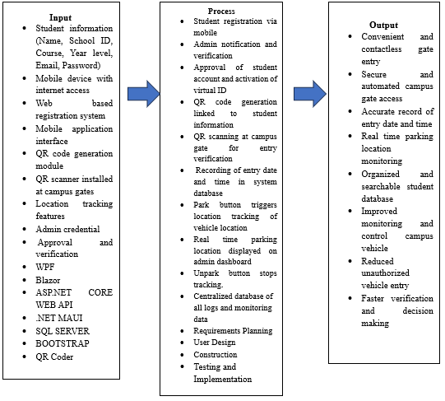
Figure 1. IPO

Input
The ParkTrack system has various inputs that comprise the required data, technologies, and resources that will be needed to operate the system. These contain details about students like name, school ID, course, year, email and password that are obtained during registration. The system further demands a mobile device, which has got access to the internet, to facilitate the user to communicate with the platform. There is also a web-based system of registration and mobile application user interface to help users interface with the system. The QR code generation module is applied to generate unique QR codes to identify them and the verification is done at the gates of the campuses by using the QR scanners. The system is also integrated with location track facilities to keep track of the parking positions as they occur. In addition, administrative features like the credentials to administer and approval and verification to verify are provided to ascertain secure access and validation to confirm user registration is proper. Additionally, the system is created based on a variety of technologies and tools such as WPF, Blazor, ASP.NET Core Web API, .NET MAUI, SQL Server, Bootstrap, and QR Coder to facilitate the role of the ParkTrack system, its functionality, database management, user interface design, and QR code creation.

Process
The ParkTrack system begins with registering the student with the help of a mobile device and providing personal details. Upon registration, the notification is sent to the admin and the details are verified. After approval, the account of the student is opened and a virtual ID with QR code is created. Then the student scans this QR code at the campus gate where it gets scanned and the system recognises the identity and the date and time when he/she enters the campus is recorded. Once entered, the student will be able to use the “Park” button in the mobile application to monitor the position of his/her vehicle which is also displayed on the affected dashboard in real time. When the student is out of the room they press the Unpark button to put off the tracking. The system database retains all the information such as the time of entry and parking to be monitored and referred to in future. ParkTrack system is based on the Rapid Application Development (RAD) which consists of Requirements Planning, User Design, Construction and Testing and Implementation. On Requirements Planning stage, the system determines what is required including student registration, QR code verification, parking tracking and approval by the administration. In the User Design stage, the system would be designed in such a way that administrators and students find it easy to operate. Construction step is oriented on the creation and assembly of various components of the system, such as the mobile application, web registration, QR code creation, and database. Lastly, during the Testing and Implementation stage, every functionality is verified to ensure that all things are in order before the system is utilized to the full.

Output
The ParkTrack system output provides safe and efficient management of access and parking of the vehicles in the campus. It can facilitate the comfortable and non-contact entry to the gate via the assistance of QR code scanning and safe and automatic access control. The system also records the right entry date and time as well as real time tracking of the parking sites. It also possesses searchable and well ordered database of information on students and vehicles. In addition to this, the system has the consequence of improving the monitoring and control of vehicles within the campus, reduce the presence of unauthorized access, and support faster verification and decision-making by administrators.

Chapter 5
Design and Methodology

Project Methodology
Rapid Application Development refers to a software development approach that emphasizes on speed, flexibility and interaction with users frequently (Agarwal, 2000). Compared to the old approaches where it may take a long time to develop the final product, RAD enables developers to develop the working components of the system in a short period after which they can enhance them with the help of the people that will actually use the system (Berger, 2009).
This approach is highly applicable in system such as ParkTrack where timely implementation and precision in the monitoring process are significance. It enable the development team to test ideas and present prototypes and make changes prior to the completion of the system (Sihimbong, 2023a). RAD also simplifies the process of dealing with requirements changes due to the fact that the system is composed of small parts that are easy to manage rather than collectively (Sihombing, 2023b).
Following the comprehension of RAD, the development of ParkTrack is broken down into four stages, that is, Requirements Planning, User Design, Contruction, and Testing and Implementation. One of the aspects of collaboration, speed, and feedback is central to every phase to make sure that system is effective in monitoring the student vehicles and campus parking.
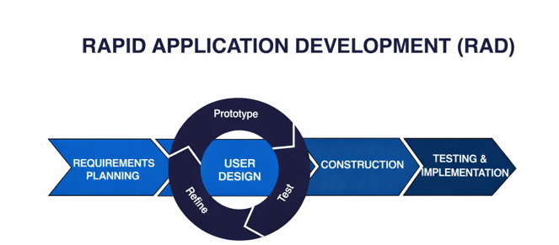
Figure 2. RAD

Phase 1: Requirements Planning
During this stage, the primary objective will be to formulate the issues of the existing vehicle monitoring and parking system and establish the aims of ParkTrack. The current procedure is largely manual and results to poor record and therefore causing challenges in the tracking of parked vehicle with in campus. Visual checking are the common security tools of the security personnel, and they are prone to human error. As such, the system aims at offering a swifter, more precise, and secure way of tracking student vehicle (Agarwal, 2000 and Berger, 2009).
Student registration via mobile web application, notification and approval by an administrator, virtual ID with a QR code, scanning a gate in order to record entry time and date, and parking/unparking functionality to trace where the vehicle is located are the functional requirements. There are also non functional requirements, including security, usability, reliability, and live data updates, as they help make sure the operation is smooth (Sihombling, 2023a). These requirements ensure that the system has to do and how to do it in actual campuses.
The development team evaluates the existing process of student entry and parking with in the campus to find out the inefficiencies and ways to improve it. The main functionalities such as registration, QR scanning and parking monitoring are to be developed. Such priority contributes to the incremental and loose character of RAD (Berger, 2009).
Responsible
The project team is in charge of the requirements gathering process and makes sure that the system will satisfy the needs of the campuses. The system analyst records and systematizes the user requirements in form of clear requirements, which are feasible and consisten. Administrators, security staff, and students make their feedback to ensure that the system is based on real life functionality (Sihombing, 2023b).
Outcomes
The deliverables of this step are expected to include a refined and prioritized system requirements and features list, a common understanding of the stakeholders and a list of feature priorities, which will be used to develop the system in small steps. Such alignment decreases the confusion and permits the delivery of the most vital system functions first (Agarwal, 2000 and Sihombing, 2023).

Phase 2: User Design
The given phase is concerned with the creation of the interface design and workflow of ParkTrack. Samples are developed to demonstrate how student will enroll, how the administrator will accept users, how the virtual ID with QR code is formed and how the gate scanning and parking/unparking system is going to work. Such prototypes are screen layout, navigation flows, simulated system interactions (Sihombing, 2023b).
Users are given prototypes to provide their opinions. Recommendation on the usability, clarity and navigation are integrated in several iterations. This will make the system easy to use and up to the expectations. Simulation of workflows, including QR scanning at the entrance, are useful in revealing and fixing possible design errors during the early stage (Berger, 2009).
Responsible
UI/UX designers are concerned with the interface and prototypes, whereas developers make sure that design are viable. Students and administrator are the end users who give feedback to enhance the system functionality and usability (Sihombing, 2023a).
Outcomes
The delivery of this stage is a tested system prototype, which is used as the guideline to development. The problems in usability are fixed at the early stage, which saves time and minimizes the risks. Users develop trust in the system and it is will accepted during implementation (Agarwal, 2000, and Berger, 2009).

Phase 3: Construction
The prototypes that are approved at this stage are then turned into a completed functioning ParkTrack system. The important functions introduced in this stage are the student registration, approval by the administrator, QR codes production, gate scanning, entry recording, and parking /unparking. It also includes the creation of a secure database to keep the data concerning students, vehicles (Sihombing, 2023a).
The development is done in an incremental manner with the critical modules being done first. The testing goes hand in hand with the development process thus any mistakes that are made can be corrected at an early stage and make the system to be stable and reliable. It is also a stage where performance optimization is done in preparation of the system to be deployed and to be used in real time (Agarwal, 2000).
Tools
WPF with MVVM, Blazor, ASP.NET Core Web API, SignalR, .NET MAUI, Geolocation, SQL Server, Bootstrap, and QR code generation.
Responsible
The coders and integrations are the developers who deal with the code and integration processes, the testers who are the quality assurance staff who test and detect defects and correct them and the project manager who keeps track of the project to ensure that it is within schedule (Berger, 2009).
Outcomes
The outcome is a functioning ParkTrack system that has all that has all the main features in place. The stability and reliability of the system can be enhanced with constant testing and debugging. Technical documentation is also generated so that it can aid in maintenance and updates in the future (Sihombing, 2023b).

Phase 4: Testing
This stage entails the last minute testing and release. Every aspect of the system is put in test such as registration, administrator approval, QR scan, record of entry and parking. All the outstanding problems are resolved prior to complete implementation. Omce tested, the system is deployed and set up on the campus premises, and real time processes are checked to make sure that the system functions correctly (Sihombing, 2023a).
Administrator, security personnel and students are subjected to training. They are taught how to register, scan QR codes, and parking/unparking functions. They also provide user manuals to avoid poor usage. Monitoring is done after the deployment to seek user feedback and make slight modification where necessary (Berger, 2009).
Responsible
The system is configured and installed by the deployment team. Users can be supported by support staff with technical issues, and administrator are in charge of system policies and operations (Sihombing, 2023b).
Outcomes
The end result is a ParkTrack system that is fully operational. The speed and security of access to gates increase, vehicles are monitored in real time, and mistakes in monitoring by hand are minimized. Training and support increase user acceptance, which leads to a more effective campus vehicle monitoring (Agarwal, 2000, and Sihombing, 2023a).

Project Design

Requirement Analysis
DFD Level 0. The Student and Admin are external parties and they interact with the system in this diagram. The system then accepts the registration information provided by the student to create an account and after account is approved, the student is issued with a virtual ID that they may be identified with. The student is also capable of doing park and unpark, which are logged in by the system. Conversely, the system provides the notification to the admin about the student registration and activities. The admin will be in charge of approving or declining the registrations, keeping an eye on the parking of students, and accessing the records or reports created by the system. This figure depicts that ParkTrack system is the hub in which communication, registration, parking activities, and monitoring in the campus are coordinated.
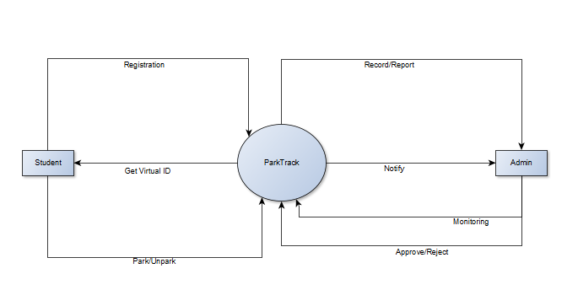
Figure 3. DFD Level 0
DFD Level 1. The Level 1 Data Flow Diagram indicates the specifics of the process of the system and the flow of data between the student, the admin, and the system database. The process starts with the student giving his or her details by way of the registration process. The registration information is then received in database and a notification is sent to the admin to alert him about the new registration request. The administrator is able to check the student information and control the registration.
Once the student has been registered, he or she is able to scan in using his/her virtual ID upon entering the campus. The scanning process catches the scanning information and forwards the data to the record process where the entry information is recorded in the database. The student is also able to carry out the parking activities like park and unpark which are updated and recorded in the system. Alerts are also created to alert the admin of the new registrations, scans, and parking updates to track the same.
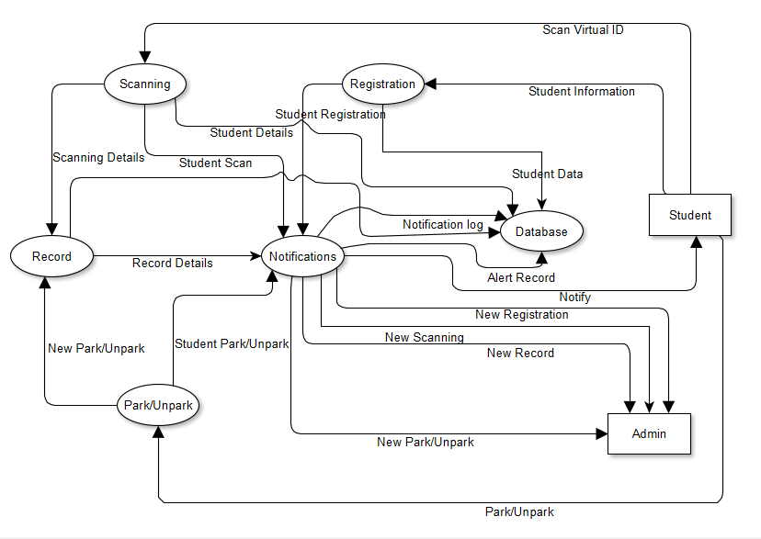
Figure 4. DFD Level 1

Technical Feasibility. The existing mechanism that is used to track the student vehicles is dependent on the manual documentation of all the vehicles and their verification by the security guards and this is time wastage and subject to errors. To enhance this, the proposed ParkTrack will make use of modern technologies to automate the parking management. The administrator interface will be built using Windows Presentation Foundation (WPF) and Model-View-ViewModel (MVVM) architecture to create an easy to understand and maintain desktop application, with all data such as the student information and entry logs stored in the SQL Server. The system will be communicated with the database via the Asp.net core web API and all the data such as the student information and entry logs will be stored in the SQL server. Students will be able to access the system via a mobile web application developed using Blazor, therefore they do not need to install The reason behind selecting these technologies is that they are dependable, simple to install, and can be improved upon in the future. As a demonstration, Blazor can be used to create interactive web apps in C# and thus make them compatible with the rest of the system whereas WPF with MVVM can be used to provide a structured design of the admin interface. In general, the suggested configuration would be more efficient, accurate, and flexible than the existing manually run system.
Schedule Feasibility. ParkTrack system can be considered schedule feasible since the project schedule fits within the four month period it has. January to February will involve requirements planning stage which will aim at getting system requirements and setting objectives so as to get a clear picture of what the system needs. User Design phase will slightly overlap with the User Design since it will begin in February and run through June to enable the creation of diagrams and interface layouts as the requirements become solidified. Construction (Coding) phase will take place between April and November providing sufficient time to deploy the admin interface, student mobile web interface, database, and communication services. Lastly, October to December 26 is the Testing and Implementation where system testing, debugging and implementation will take place before the project is completed. The developed timeline will provide every stage with enough attention without unjustified delays and the creation of ParkTrack will be possible within the established period of time.
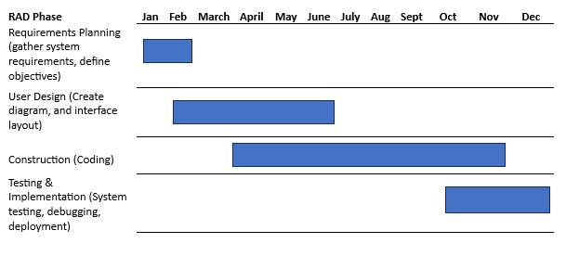
Figure 5. Gantt Chart

Design of Software, Systems, and Processes
System Flow. The system flow begins with administrator and student logging to the system using their accounts. Logging in, the administrator has access to the dashboard where one can view the registered students, scan the student QR code to enter the campus, track the parking activities and see the records that are registered in the system. These can assist the administrator control the vehicle entry, and parking of the students within the campus. Conversely, the student will also be offered an opportunity to use the dashboard where they can do their registration, see their virtual ID with a QR code, and consult the reports within the system. The virtual ID is used when the student gets into the campus as well as when they scan when exiting the campus and can update their parking or unparking status. Once they are done with their work, the administrator and the student can leave the system so that they can terminate their session.
System flow diagram Admin. The administration system starts with the administrator signing into the platform where he/she is allowed to access the main dashboard. The admin can reach out to various modules via the dashboard like scanning student QR code to enter campus, parking activity, registered students and historical records. All of these functions enable the admin to effectively deal with student vehicle tracking and campus parking. After the required work is performed, the admin might log out to terminate the session making sure the security and reasonable termination of the system.
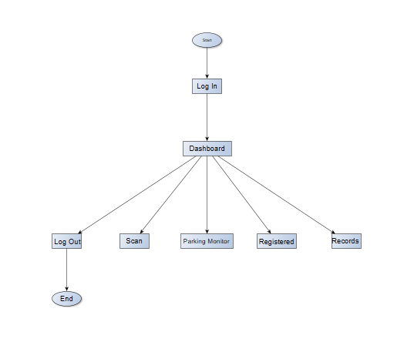
Figure 6. System flow Admin

System flow diagram Student. The student system flow begins as the user opens the system and logs in to the system using his account. Once the student has successfully logged in, they are led to the dashboard that is the primary page on which various system features can be accessed. Through the dashboard, the student is able to select various options that include viewing their Virtual ID, completing or maintaining their Registration and accessing the Reports that are within the system. Once the student is through with the system, they can choose the Log Out option that will terminate the student on the system and thus conclude the process.
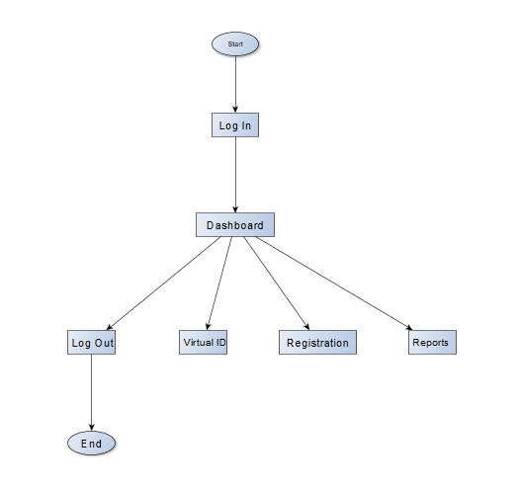
Figure 7. System flow Student

Use Case Diagram. The ParkTrack use case diagram indicates the interaction between the students and the system and the administration. Students have an opportunity to enroll, swipe their virtual ID, park or unpark their cars and see records. These processes are also accessible to the admin that will be able to approve registrations, track entries, and administer student parking data. This figure indicates the way the system is used by the student and the admin to monitor the vehicle access and parking.
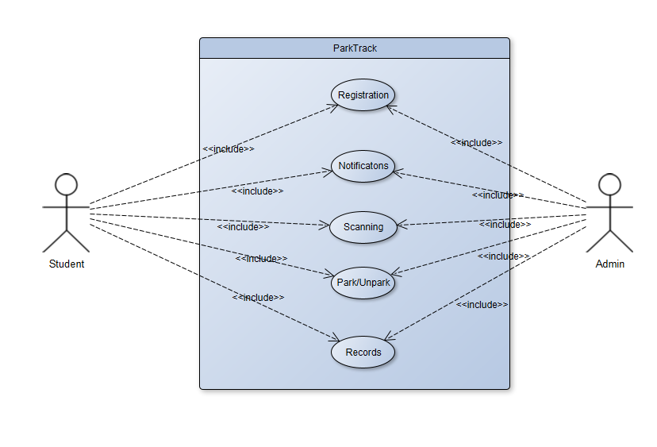
Figure 8. Use case Diagram
Table 1. Use Case Specification
User Case | Brief Description | Pre-Condition | Flow of Event | Post-Condition
Registration | The student registers their personal and vehicle information through the ParkTrack mobile web system. | Student is not yet registered in the system. | Student opens the registration page, fills in required details (name, studentID, course, year, email, and password ), and submits the form. The system sends the registration request to the admin. | Registration request is stored and waiting for admin approval.
Notifications | The system sends notifications to the admin when a new student registers and notifies the student once the account is approved. | Student has submitted a registration form. | The system automatically sends a notification to the admin. Admin reviews the request and approves it. The system then notifies the student of the approval. | Student account becomes active and ready to use.
Scanning | The QR code from the student's virtual ID is scanned at the campus gate to verify entry. | Student must have an approved account and a generated QR code. | Student opens the virtual ID on their mobile device and presents the QR code at the gate scanner. The system scans the QR code and displays the student details, date, and entry time. | Entry is recorded in the system and the student is allowed to enter the campus.
Park / Unpark | The student indicates whether the vehicle is parked or leaving the parking area using the mobile system. | Student must have already entered the campus through QR scanning. | After parking the vehicle, the student presses the Park button in the mobile web system. The system records the parking and displays it on the parking monitor for the admin. When leaving the parking area, the student presses Unpark to remove the vehicle from monitoring. | Parking location is updated in the system and removed from the monitor once the student unparks.
Records | The system stores and allows viewing of parking and entry records for monitoring purposes. | Student must have existing parking or entry records in the system. | Admin or student accesses the records section to view parking history, entry time, and exit information. | Parking and entry records are displayed for monitoring and tracking.

Sequence diagram Admin. Admin Sequence Diagram shows the interaction between the Notification Process, Admin, and Student when registering approval is underway. First, there is the Notification Process whereby, a notification is sent to the Admin requesting to approve a student registration. The Admin then looks at this request and makes a decision on whether or not to approve or reject the student. When the decision is made, the Admin makes the response available to the Notification Process. Lastly, the system transmits the approval and the rejection status to the Student. This will enable the Admin to analyze registration requests and easily manage the approvals of students.
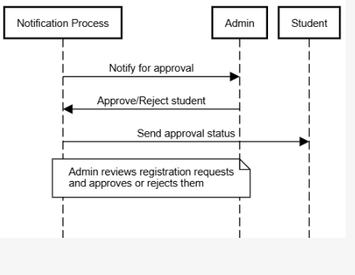
Figure 9. Sequence Admin
Sequence diagram Student. The Student Sequence Diagram depicts the interaction between the student and the system as a part of the registration process. To begin with, the student becomes a registered user by forwarding his or her information to the registration process of the system. When the information is received, the system then stores the student details in the database in order to maintain the records. After saving the data, the system will be sent a request to be registered by the notification process so that it can then be reviewed and allowed. Once the registration has been submitted, the approval is awaited and then the student will be able to fully utilize the system and its functions.
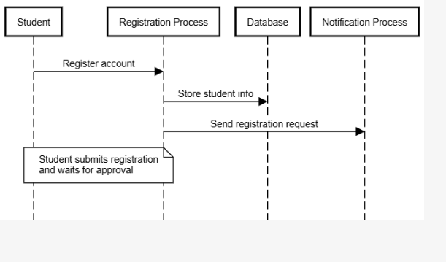
Figure 10. Sequence Student
Sequence Diagram Registration. Registration Sequence Diagram depicts how a student opens the account within the system. The initial stage involves the student registering through requesting registration: the student fills the necessary information in the registration form and submits it. The student data is then received by the registration process that receives and processes the information of the student. Subsequently, the system puts the details of the students in the database so that it will be stored in the system. After the registration, the student will await the approval after which the account will be able to be fully utilized in the system.
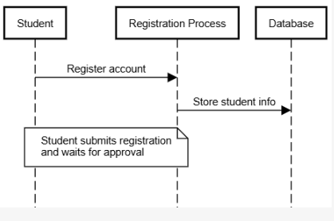
Figure 11. Sequence Registration

Sequence Diagram Notifications. This Notifications Sequence Diagram is used to display the student registration approval process in terms of notifications. The Registration Process first passes a registration request to the Notification Process. The Admin is then informed by the Notification Process that a new student registration is required. Upon getting this notification, the Admin goes through the request and makes the decision of approving or rejecting the registration of the student. The decision of the Admin is returned to the Notification Process, where the last approval status is dispatched to the Student. This process will make sure that the Admin goes through the registration request and that the Student gets a feedback on whether their registration is approved or rejected.

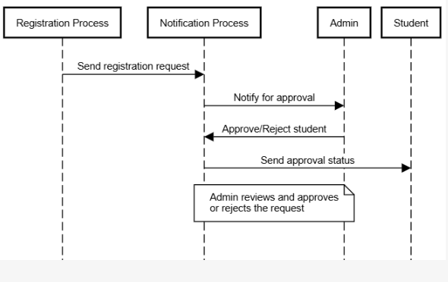
Figure 12. Sequence Notifications
Sequence Diagram Scanning. This Scanning Sequence Diagram illustrates the access of a student into the campus via a QR code scanning system. The Student then scans his or her QR code, which asks to be admitted into the campus. The request is passed to the Scanning Process which reads and scans the scanned QR code. Once the QR code has been scanned successfully, the system registers the entry by transferring the information to the Database to record the entry of the student. This is done to make sure that all entries of the students are recorded and stored in the system to monitor and record.

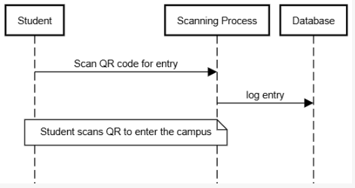
Figure 13. Sequence Scanning
Sequence Diagram Park/Unpark. This Park/Unpark Sequence Diagram provides the way the system takes care of parking and un-parking of vehicles once the scanning process is completed. The Park/Unpark Process then makes the correct updating of the Database with the most recent parking information. The system also updates the vehicle parking location in the Campus Map upon the database update. This will enable the parking position to be represented and traced on the map live, which will assist users and administrators to monitor the parking vehicles positions on campus.

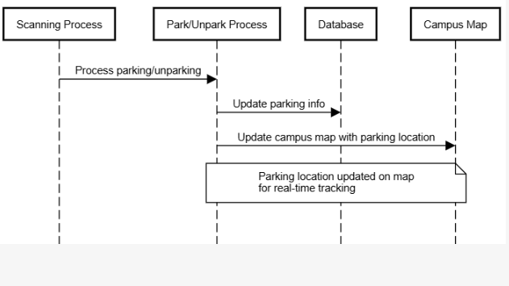
Figure 14. Sequence Park/Unpark
Sequence Diagram Records. Records Sequence Diagram is used to show the communication between the Database and the Admin in dealing with the student vehicle and parking records. The first one is that the Admin makes a request to the Database to access student records. The Database will take the request and give out the student information, which will be shown to the Admin. An Admin, after viewing the information, is able to administer the records by either adding, editing, or deleting information of student vehicles/parking. The Database in turn updates the records and forwards the updated information to the Admin. By so doing, the Admin can track and control records of vehicles and parking of students.

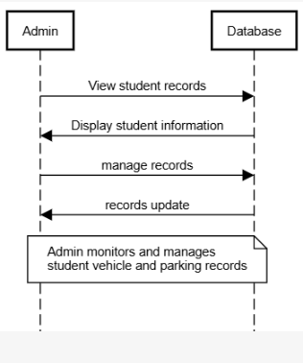
Figure 15. Sequence Records

Design Class Diagram. The class diagram indicates the key classes with the system and their relationships with each other. Student class has the IDs of the students and their names, email and virtual ID, functions of registering and scanning the virtual ID. Registration class takes care of the registration process and stores the registration ID and status. Admin class is obliged to approve or reject registrations, see reports and track system activities. Scanning class handles the scanning process of QR codes and verification of the student ID, whereas the Record class is used to store the entry details including record ID, entry time, and parking status and can provide reports. The Notification class is used to notify the users of updates like registration approval. These classes collaborate to control student registration, QR code scanning, and the parking monitoring of the system.
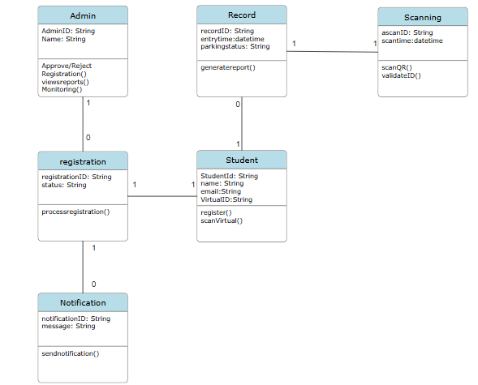
Figure 16. Class diagram
Class Student. Student class has the IDs of the students and their names, email and virtual ID, functions of registering and scanning the virtual ID.
Class Registration. Registration class takes care of the registration process and stores the registration ID and status.
Class Admin. Admin class is obliged to approve or reject registrations, see reports and track system activities.
Class Scanning. Scanning class handles the scanning process of QR codes and verification of the student ID.
Class Notifications. The Notification class is used to notify the users of updates like registration approval.
Class Record. Record class is used to store the entry details including record ID, entry time, and parking status and can provide reports.
Entity Relationship Diagram. This ERD depicts a system to be applied to manage student scanning records. Student entity contains the details of the students like StudentID, Name, Email, Password, Course, and Year. A student can create numerous Logs whenever they scan their ID recording information such as ScanID, StudentID, Name, Year, Course, Time and Date. This forms a one to many relationship whereby a single student may have numerous scan logs. The Admin entity holds the logon details of the administrator with the following details in it; AdminID, Username, and Password. The student records in the system are to be maintained and followed up by the admin. This association also depicts that an admin will be able to handle multiple students, and each student will be linked with one administrator in the system.
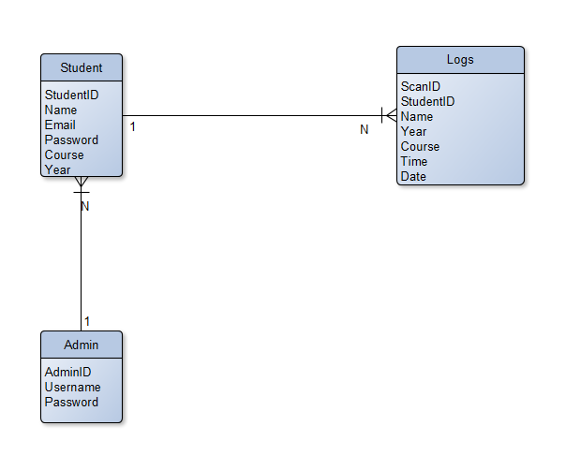
Figure 17. ERD
Entity Student. Student entity contains the details of the students like StudentID, Name, Email, Password, Course, and Year. A student can create numerous Logs whenever they scan their ID recording information such as ScanID, StudentID, Name, Year, Course, Time and Date.
Entity Admin. The Admin entity holds the logon details of the administrator with the following details in it; AdminID, Username, and Password.
Entity Logs. The student records in the system are to be maintained and followed up by the admin.

Development and Testing
During the development stage using the approved system design and requirements. The windows presentation foundation (WPF) along with the Model-View-ViewModel (MVVM) architecture will be used to create the administrator side of the system so that it has a well-organized, maintainable structure. The student interface will be created in the form of a mobile web-based application with the help of Blazor in order to provide students with the opportunity to easily access the system with the help of their mobile devices. It will be implemented with ASP.NET core Web API to support communication between the application and the database, and all system data including student data, and entry logs will be located in the SQL Server. During this stage, all fundamental capabilities of the system such as registration, the creation of QR codes, scanning, and parking tracking will be written and connected.
Once the development process has been made, the system will be tested to see whether all the functions work well and match the requirements of the system. Some of the areas that will be tested include student registration process, scanning of QR code at the entrance of the campus, parking and un-parking operations and notification of the system. The developers will also perform tests on the system to ensure that it is reliable and simple to use by the administrators as well as students. The problems or mistakes detected during this stage will be rectified and addressed as soon as possible before the system is formally introduced.

Description of the Prototype
This Phase the system displays the admin login page of ParkTrack where the admin enter the email address and the password. In the left bottom the admin can click the forgot password when he/she forget the password so that it can still access the log in.
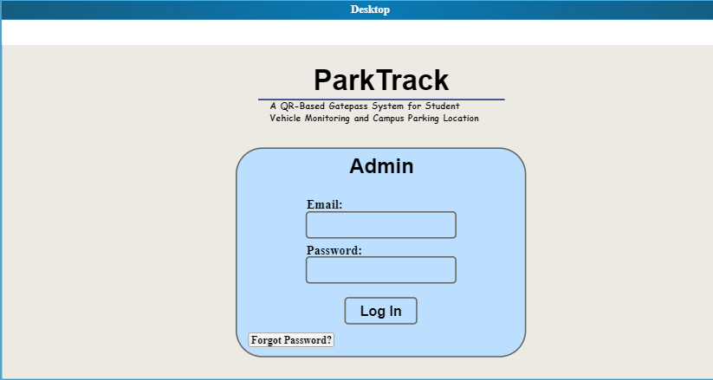
Figure 18. Admin log in page
The dashboard of ParkTrack is the main page where the administrator can view and manage all system activities. It shows a summary of important information such as the total scans for today, the number of vehicles parked, and the latest scan details. The left side menu allows admin to navigate to different sections like Scan Gatepass, Parking Monitor, Registered, and Records. At the bottom, the latest scan log displays student information including name, student id, course, year, time of entry, and date.
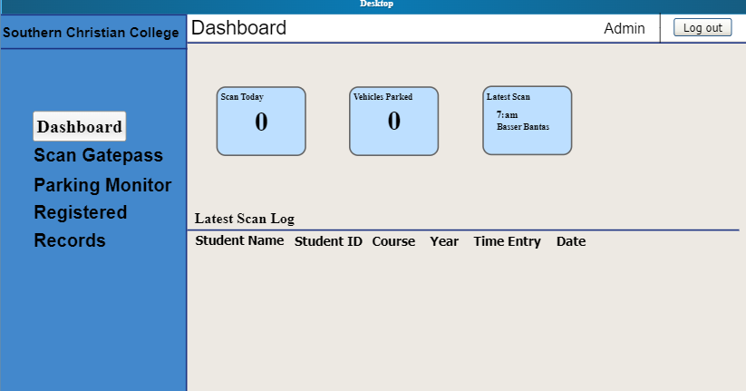
Figure 19. Dashboard
The Scan Gatepass page of ParkTrack is where the administrator scans the student virtual id with QR code to record their entry. Once the QR code is scanned, the students information automatically appears on the screen, including name, student id, course, year, time of entry, and date. It ensures that only registered and approved users in the system are allowed to enter.
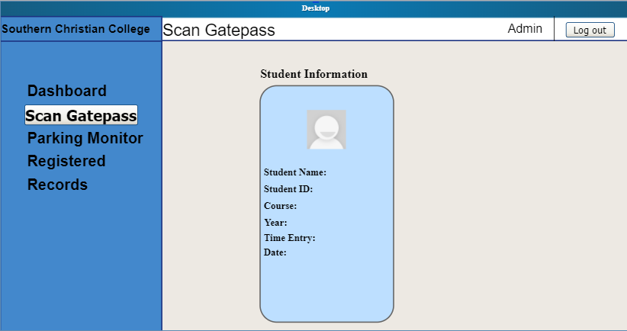
Figure 20. Scan Gatepass
Parking Monitor enables the administrator to view the campus map and locate the position of each student who has parked his/her vehicle. It shows the parking area layout, helping the admin easily monitor vehicle locations inside the campus. This page helps maintain organized parking and ensures proper monitoring of all parked vehicles.
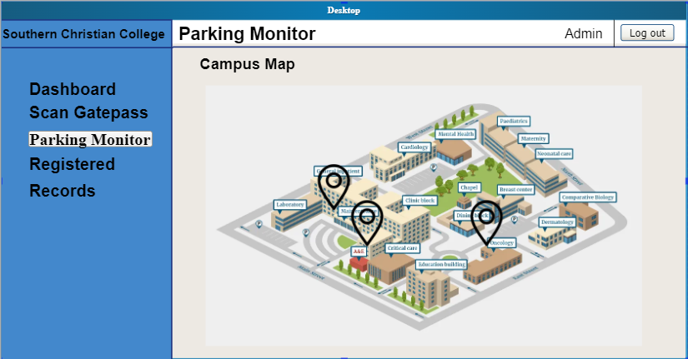
Figure 21. Parking Monitor
Registered page display all student who have submitted their registration in the system. Every registered student must be approved by the administrator before gaining access. Once the admin approves the registration, the student can use their virtual ID with a QR code to enter the campus. This process ensures that only approved students are allowed to use the system.
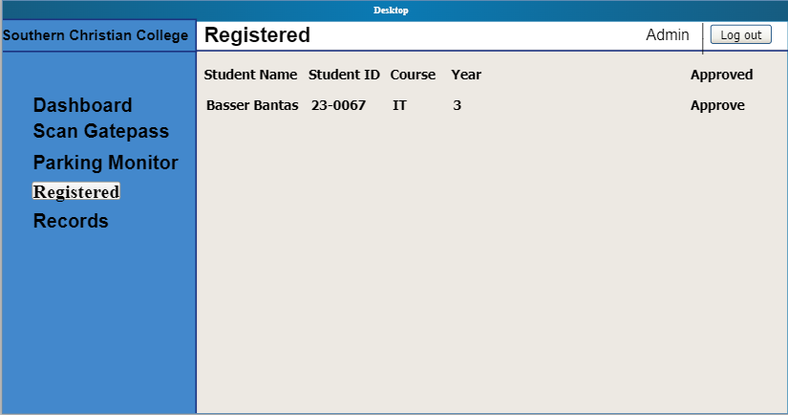
Figure 22. Registered
The records page shows all students who have entered the campus. On this page, the is given a full record of individual student and this includes the student name, ID, course, year, time of entry, and date. It allows the admin to easily review all student entries and if the student click the park it will display into records, same as the unpark button.
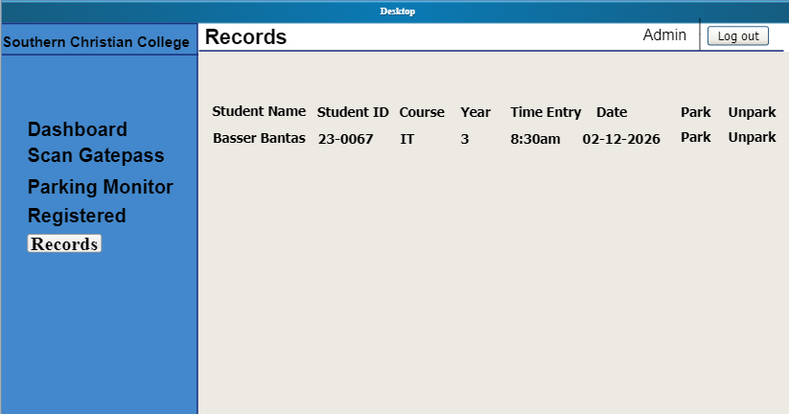
Figure 23. Records
The log in page for the users should the users enter their email and password to open their virtual ID with a QR code once the admin has approved their registration. If the admin hasn’t approved them yet, they cannot access the system. Users who are not yet registered can click the register button to sign up and send their registration for admin approval.
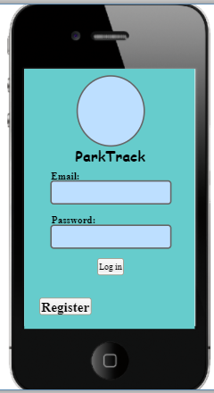
Figure 24. Student Log in page
Registration page where new users can sign up in the system. It has fields for student name, ID, email, password, course, and year, and a register button at the bottom. Users fill out these details to submit their registration, which the admin must approve before they can access the system.
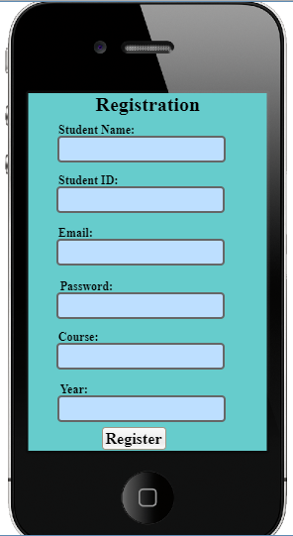
Figure 25. Registration
In this page is the user page it display their the dashbord, the total entries, the total park/ unpark and the last entry of the user. After that in the left side the menu icon there is where the dashboard, registration, virtual id and lastly is the reports on the right side it display the log out button when the user want to exit.
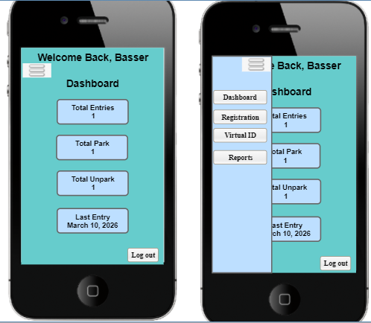
Figure 26. Dashboard
This is where interface of registration update when the student want to update his/her name, id, password, course and year. In the left corner it has a button of back when the student finish the update process and in the right side it has a log out button if the student want to log out and in the left at the top there a back button if they want to exit the Registration Update.
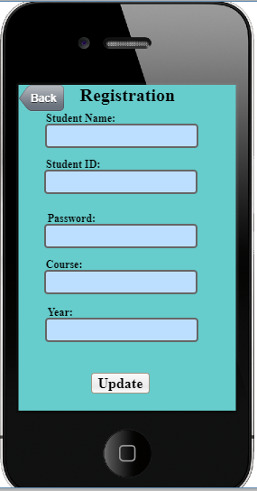
Figure 27. Registration Update
This page is where virtual id display including the student name, student id and course. It also display the QR code of the user, at the bottom where the user can click the Park for the admin to have an access were location they park and in the right side it has a log out button if the student want to log out and in the left at the top there a back button if they want to exit the Virtual ID.
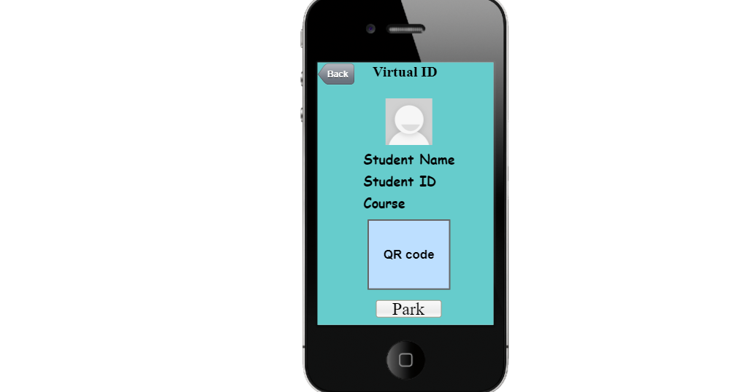
Figure 28. Virtual ID
This page is where the reports display including the entry log of each student about the date they enter the campus also the time they arrive. In the buttom it display the parking activity on what date they park, the time they park within the campus and also the time they unpark and in the left at the top there a back button if they want to exit the reports.
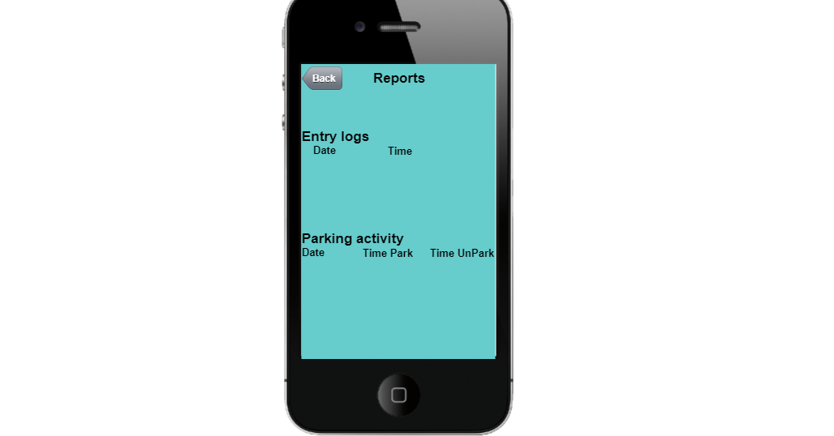
Figure 29. Reports

Literature Cited
Agarwal, R., Prasad, J., Tanniru, M., & Lynch, J. (2000). Risks of rapid application development. Communications of the ACM, 43(11es), 1-es.
Aguilar, J. M. (2014). SignalR Programming in Microsoft ASP. NET (Vol. 40). Microsoft Press.
Ahmed, A. A., Al-Sanjary, O. I., & Kaeswaren, S. (2020, June). Reserve parking and authentication of guest using QR Code. In 2020 IEEE International Conference on Automatic Control and Intelligent Systems (I2CACIS) (pp. 103-106). IEEE.
Al Amin, I. H., Lusiana, V., Hartono, B., & Wahyu, D. (2024). QR Code-Based Attendance System for Contact Tracking Post-Pandemic. CogITo Smart Journal, 10(1), 15-29.
Barnett, N., & Crutchfield, J. P. (2015). Computational mechanics of input–output processes: Structured transformations and the ϵ-transducer. Journal of Statistical Physics, 161(2), 404-451.
Bazshushtari, K., Lee, A., & Ragasa, C. (2016). Smart Packing With QR-Improving Cal Poly's Parking System for All Users.
Berger, H., & Beynon‐Davies, P. (2009). The utility of rapid application development in large‐scale, complex projects. Information Systems Journal, 19(6), 549-570.
Bhattarai, I. B., Bhandari, A., Pokhrel, N., Adhikari, A., & Baral, H. P. (2024). QR-based canteen management system. Journal of Information Technology and Digital World, 6(3), 217-227.
Chakraborty, S., & Aithal, P. S. (2023). MVVM Demonstration Using C# WPF. International journal of applied engineering and management letters (IJAEML), 7(1), 1-14.
Chaudhuri, S., & Narasayya, V. R. (1997, August). An efficient, cost-driven index selection tool for Microsoft SQL server. In VLDB (Vol. 97, pp. 146-155).
Doty, N., Mulligan, D. K., & Wilde, E. (2010). Privacy issues of the W3C Geolocation API. arXiv preprint arXiv:1003.1775.
Elbehiery, . (2019H). Enhancement of QR code student’s attendance management system using GPS. Iosr Journal Of Computer Engineering (Iosr-Jce), 21(4), 18-30.
Eme, O. (2024, January). QUICK RESPONSE (QR) CODE-BASED IDENTITY CARD PROCESSING AND AUTHENTICATION SYSTEM FOR EDUCATIONAL INSTITUTIONS.
Galais, C., Fernández‐Martínez, J. L., Font, J., & Smith, G. (2021). Testing the input‐process‐output model of public participation. European Journal of Political Research, 60(4), 807-828.
Himschoot, P. (2020). Microsoft Blazor. Apress.
Ilgen, D. R., Hollenbeck, J. R., Johnson, M., & Jundt, D. (2005). Teams in organizations: From input–process–output models to IMOI models. Annual Review of Psychology, 56, 517–543.
Li, B., Kong, L., Huang, Y., Li, L., & Chen, J. (2018, December). Integration of QR Code Based on Generation, Parsing and Business Processing Mechanism. In Proceedings of the International Conference on Information Technology and Electrical Engineering 2018 (pp. 1-5).
Nair, K. D., & Mamatha, I. (2022, November). Online voting system based on face recognition and QR code authentication. In International Conference on Robotics, Control, Automation and Artificial Intelligence (pp. 619-629). Singapore: Springer Nature Singapore.
Nwabuwe, A., Sanghera, B., Alade, T., & Olajide, F. (2023). Fraud mitigation in attendance monitoring systems using dynamic QR code, geofencing and IMEI technologies. International Journal of Advanced Computer Science and Applications, 14(4), 938-945.
Omsha, B. (2024). A Comparative Study of. NET MAUI and Avalonia in Cross-Platform Mobile Application Development. - A Comparative Study of .NET MAUI and Avalonia in Cross-Platform Mobile Application Development
Pattankar, M., & Hurbuns, M. (2017). Mastering Asp. net Web Api. Packt Publishing Ltd.
Purnomo, A. T., Kim, C. S., Gondokaryono, Y. S., & Ra, I. (2017). The combining method of fingerprint and QR code as mutual authentication for mobile payment. International Journal of Control and Automation, 10(3), 345-356.
Rabu, S. N. A. (2019). The design and implementation of student attendance tracking system using QR code card. In Conference proceedings of» eLearning and Software for Education «(eLSE) (Vol. 15, No. 03, pp. 154-161). Carol I National Defence University Publishing House.
Rajangeran, A. P., Sekaran, P. S., Sidi, F., Hairani, S. R., Daud, M. F., & Razak, R. (2019, July). A STUDY ON PHYSICAL ACCESS CONTROL USING QR CODE AS VIRTUAL IDENTIFICATION SYSTEM FOR DOOR ACCESS CONTROL. In INTERNATIONAL SYMPOSIUM ON ICT MANAGEMENT AND ADMINISTRATION (ISICTMA2019) (p. 39).
Rajesh, K., Waranalatha, S. S., Reddy, K. M., & Supraja, M. (2018, June). Qr code-based real time vehicle tracking in indoor parking structures. In 2018 Second International Conference on Intelligent Computing and Control Systems (ICICCS) (pp. 11-16). IEEE.
Razak, S. F. A., Liew, C. L., Lee, C. P., & Lim, K. M. (2015, December). Interactive android-based indoor parking lot vehicle locator using QR-code. In 2015 IEEE Student Conference on Research and Development (SCOReD) (pp. 261-265). IEEE.
Richey, R. C., & Klein, J. D. (2007). Design and development research: Methods, strategies, and issues. Lawrence Erlbaum Associates.
Shaban, S., Magzoub, M. E., Elzubeir, M., Shaban, O. H., Alsuwaidi, A. R., Al-Houqani, M., ... & Mohamed, A. F. A. (2021). Developing a student attendance app using QR codes: educational and practical considerations. International journal of technology enhanced learning, 13(1), 92-106.
Sharma, P., Verma, K., Saini, H. K., Khandelwal, R., Sharma, A., & Sharma, S. (2025). Smart Attendance System Using QR Codes: Comparative Analysis and Real-World Implementation.
Sihombing, D. J. C. (2023). Development of construction inventory application with Rapid Application Development method. Jurnal Informatika Universitas Pamulang, 8(3).
Sihombing, D. J. C. (2023). Development of Occupational Health and Safety Information System in Construction Company Using RAD Method. Jurnal Info Sains: Informatika dan Sains, 13(03), 853-860.
Subiyakto, A. A., & Ahlan, A. R. (2014). Implementation of input-process-output model for measuring information system project success. TELKOMNIKA Indonesian Journal of Electrical Engineering, 12(7), 5603-5612.
Temere, B. (2017). Responsive web application using Bootstrap and Foundation: Comparing Bootstrap and Foundation Frontend Frameworks.
Wei, X., Manori, A., Devnath, N., Pasi, N., & Kumar, V. (2017). QR code based smart attendance system. International Journal of Smart Business and Technology, 5(1), 1-10.

Appendices

